NEWS COP 29 BY CLIMATE HUB FORUM WEBSITE UPDATE

Forum’s Global Voice for Climate Justice at COP 29
Empowering the Global South: Advocacy, Collaboration, and Climate Justice
Baku, Azerbaijan — COP 29 Update
The Climate Hub Forum (CHF) emerged as a pivotal force at COP 29, amplifying the voice of the Global South and calling for urgent climate justice on the international stage. Through a series of strategic dialogues, high-level engagements, and collaborative partnerships, CHF reaffirmed its role as an independent platform championing equity, sustainability, and action.

Our Mission: A Call for Equity and Justice
At the heart of CHF’s participation was a bold commitment: amplify the voices of vulnerable communities who are bearing the brunt of climate change without bearing its responsibility. CHF’s delegation pushed for:
- Equitable financing frameworks
- Technology transfer and adaptation support
- Accountability from historical emitters
With over 75% of historical emissions originating from the Global North, CHF’s call for reparative justice struck a resonant chord at multiple sessions and roundtables.

Strategic Collaborations at the Pakistan Pavilion
CHF co-led and contributed to major events at the Pakistan Pavilion, demonstrating the power of unified South-South collaboration.
Milestone Achievement: Launch of Pakistan’s National Climate Finance Strategy
CHF proudly partnered on the launch of Pakistan’s National Climate Finance Strategy, a landmark policy designed to channel climate finance effectively toward resilience and adaptation.
The event featured a keynote by Professor Dr. Phoebe Koundouri, CHF senior advisor, a globally renowned economist and sustainability expert, who praised Pakistan’s proactive leadership and highlighted the Forum’s convening role.
"This strategy is a model of how Global South countries can lead with policy innovation. CHF’s role in bridging international expertise with national priorities is commendable."
— Dr. Phoebe Koundouri

Key Focus Areas at COP 29
CHF advocated for a climate agenda centered on:
- Fair Climate Finance Mechanisms
- Equity in Global Policy-making
- Nature-Based Solutions and Biodiversity Conservation
- Community-Driven Adaptation Models
With a strong narrative on people-first development, CHF positioned itself as a policy influencer and solutions driver.

A Unified South-South Future
As COP 29 concludes, CHF is building momentum toward a united Global South voice in climate negotiations. With deep partnerships and an unwavering mission, the Forum is poised to influence both policy and practice globally.
"Climate justice must move from pledges to practice. We are not asking for aid — we are demanding accountability, equity, and sustainable partnerships."
— Aamir Sadozai, Co Founder Climate Hub Forum
Erum Khan, Chairperson of the Climate Hub Forum, emphasized that international partnerships are vital to operationalize this strategy and ensure real, on-ground impact.
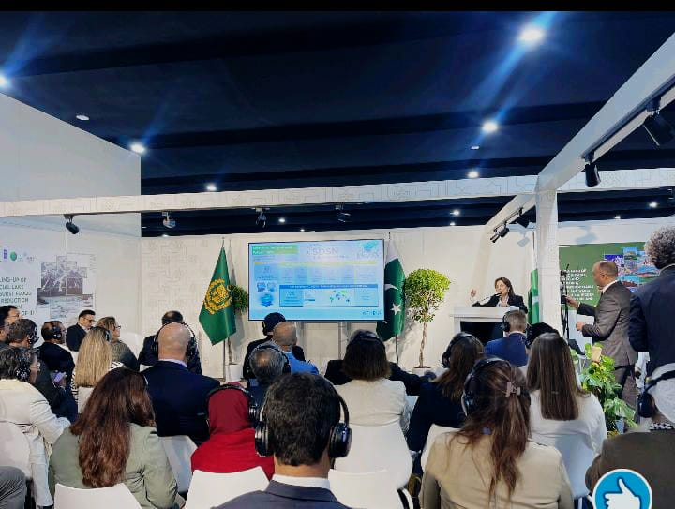

NEWS ARTICLE 2 – COP 29
Ministerial Meetings on Urbanization and Resilience at COP 29
Advancing Urban Climate Solutions for a Resilient Future
Baku, Azerbaijan — COP 29 Update
At COP 29, Climate Hub Forum (CHF) engaged in crucial ministerial sessions on urban resilience, sustainable transport, and climate adaptation, aligning Global South urban policies with international climate goals.

Key Highlights
- Launch of the Multi-Sectoral Action Pathways (MAP) Declaration
CHF supported the MAP Declaration, a strategic framework promoting resilient, healthy cities through sustainable urban practices and climate-resilient infrastructure.
- Signing of the Baku Continuity Coalition
CHF was part of the Baku Continuity Coalition, a pact ensuring sustained focus on urban climate solutions across COP presidencies.
- Positioning Baku as a Hub for Urban Climate Dialogue
Baku is positioned as a future hub for urban climate discussions, including events like the World Urban Forum 2026, continuing the momentum for global urban resilience.

🤝 CHF’s Commitment to Urban Climate Action
CHF remains dedicated to promoting inclusive urban climate policies and ensuring the voices of vulnerable communities are central in shaping global urban solutions.

What’s Next?
CHF will continue advocating for sustainable urbanization and climate-smart solutions, keeping the focus on resilient cities at future COPs and international platforms.

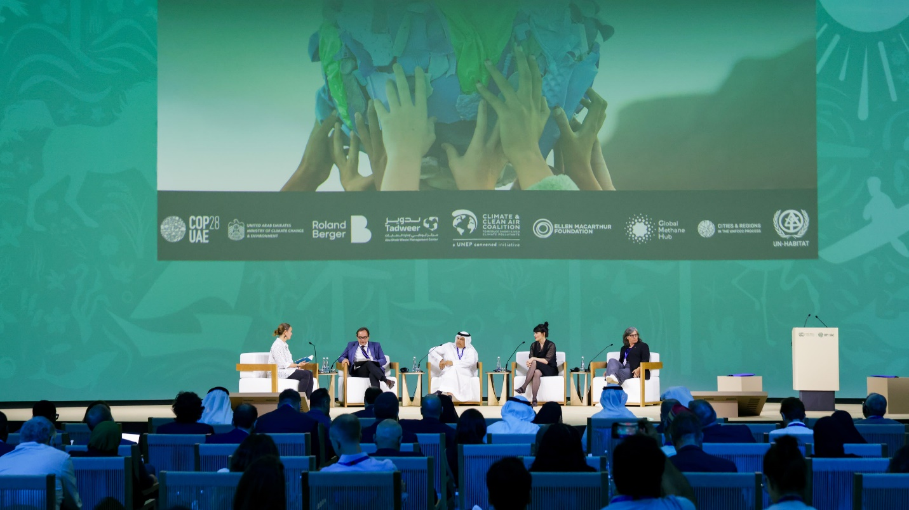

NEW 3 COP 29
High-Level Report: CHF’s Groundbreaking Partnership with Gilgit-Baltistan Government at COP 29
Executive Summary
The Climate Hub Forum (CHF), led by Chairperson Erum Khan, marked a major milestone at COP 29 in Baku, Azerbaijan, with its pivotal partnership with the Ministry of Climate Change and the Gilgit-Baltistan Forest and Wildlife Department. CHF’s leadership in hosting the high-level session "Uniting Conservation, Community, and Tourism for the Future of Gilgit-Baltistan's National Parks" highlighted its commitment to climate-resilient tourism, conservation, and community empowerment. This collaboration set the stage for actionable solutions in sustainable tourism, aligning with global climate goals.
COP 29 and the Gilgit-Baltistan Partnership
At COP 29, the tourism sector saw groundbreaking developments, including the declaration of Tourism Day and the launch of the first Ministerial Meeting on Climate Action in Tourism. CHF’s strategic partnership with Gilgit-Baltistan focused on integrating sustainable tourism with conservation efforts, especially within the region's national parks.
The high-level session led by CHF provided an unprecedented platform for dialogue on sustainable tourism practices and conservation strategies, with specific focus on Gilgit-Baltistan’s unique biodiversity and challenges. Erum Khan, alongside key figures from the Ministry of Climate Change and Gilgit-Baltistan's Forest and Wildlife Department, spearheaded discussions that set the groundwork for future climate-resilient initiatives.
Key Session Highlights: "Uniting Conservation, Community, and Tourism for the Future of Gilgit-Baltistan's National Parks"
The session served as a dynamic forum to harmonize conservation and tourism goals while empowering local communities in Gilgit-Baltistan.
Key Topics Discussed:
- Community-Driven Conservation Models: Exploring local involvement in conservation efforts to protect Gilgit-Baltistan’s diverse ecosystems.
- Climate Finance Strategies: Tailoring financial mechanisms to support conservation and sustainable tourism development in the region.
- Eco-Tourism Frameworks: Proposing frameworks that allow for sustainable tourism while preserving the region’s natural heritage.
Notable Speakers:
- Ismael, PD Forest, Wildlife & Environment Department, Gilgit-Baltistan
- Shahid Zaman, Former Secretary, Forest and Wildlife
- Mahmood Akhtar Cheema, Country Representative, IUCN Pakistan
Outcomes of the Session:
- Development of a Sustainable Tourism Framework specifically for Gilgit-Baltistan.
- Integration of tourism policies into Pakistan’s National Climate Finance Strategy

Recommendations Moving Forward:
- Integrating Tourism in National Climate Plans (NDCs): Governments should incorporate tourism-specific climate strategies into their NDCs to enhance resilience and biodiversity conservation.
- Strengthening Local Capacity: Focus on scaling eco-tourism initiatives, particularly in regions like Gilgit-Baltistan, by building local expertise and securing climate finance.
- Global South Collaboration: CHF recommends establishing a network for the Global South to share best practices, mobilize climate finance, and promote cross-border tourism strategies.
- Private Sector Engagement: Encouraging private sector investments in sustainable tourism with incentives such as green finance and international recognition.
- Community-Centric Tourism Models: Emphasizing the need for community-led tourism initiatives that ensure equitable distribution of benefits.
Future Plans and Strategic Recommendations
The outcomes of CHF’s partnership with Gilgit-Baltistan’s government and its active role at COP 29 have set the stage for continued advocacy and action in climate-resilient tourism.
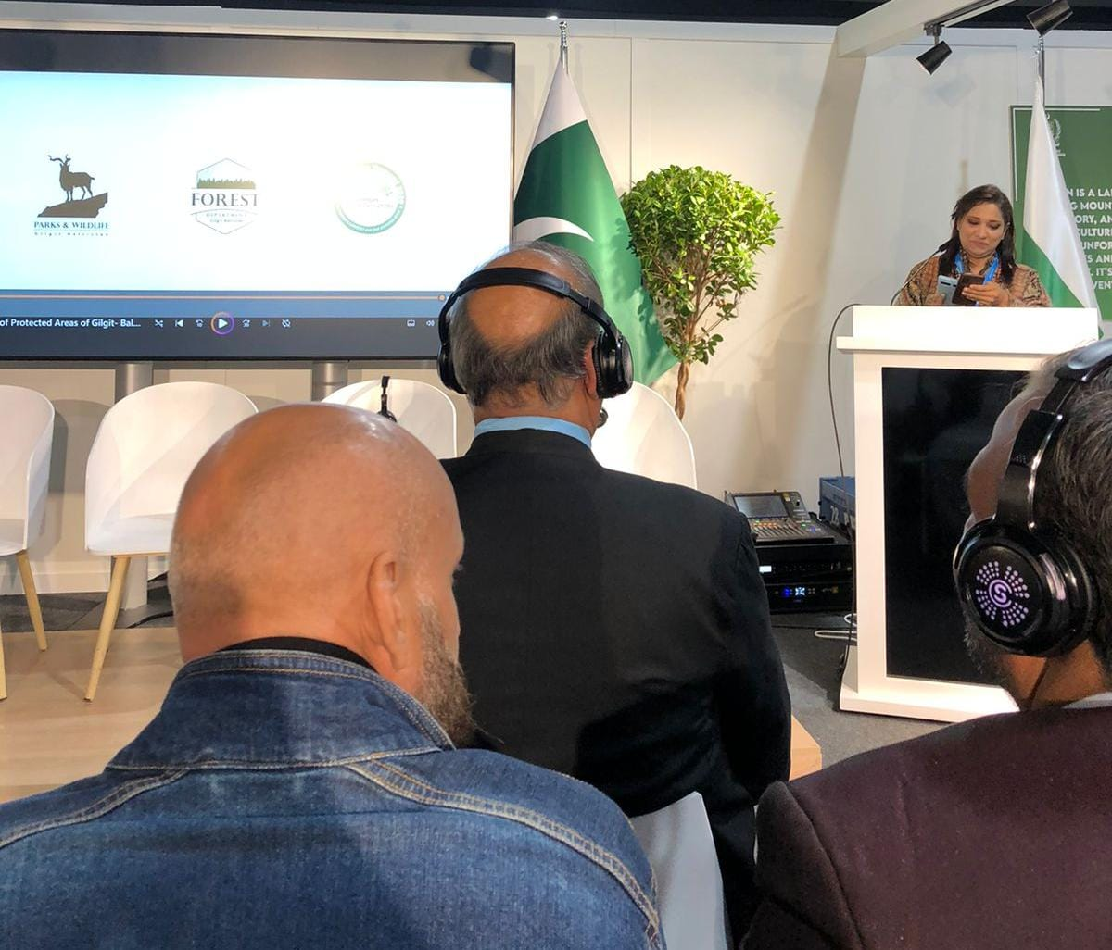
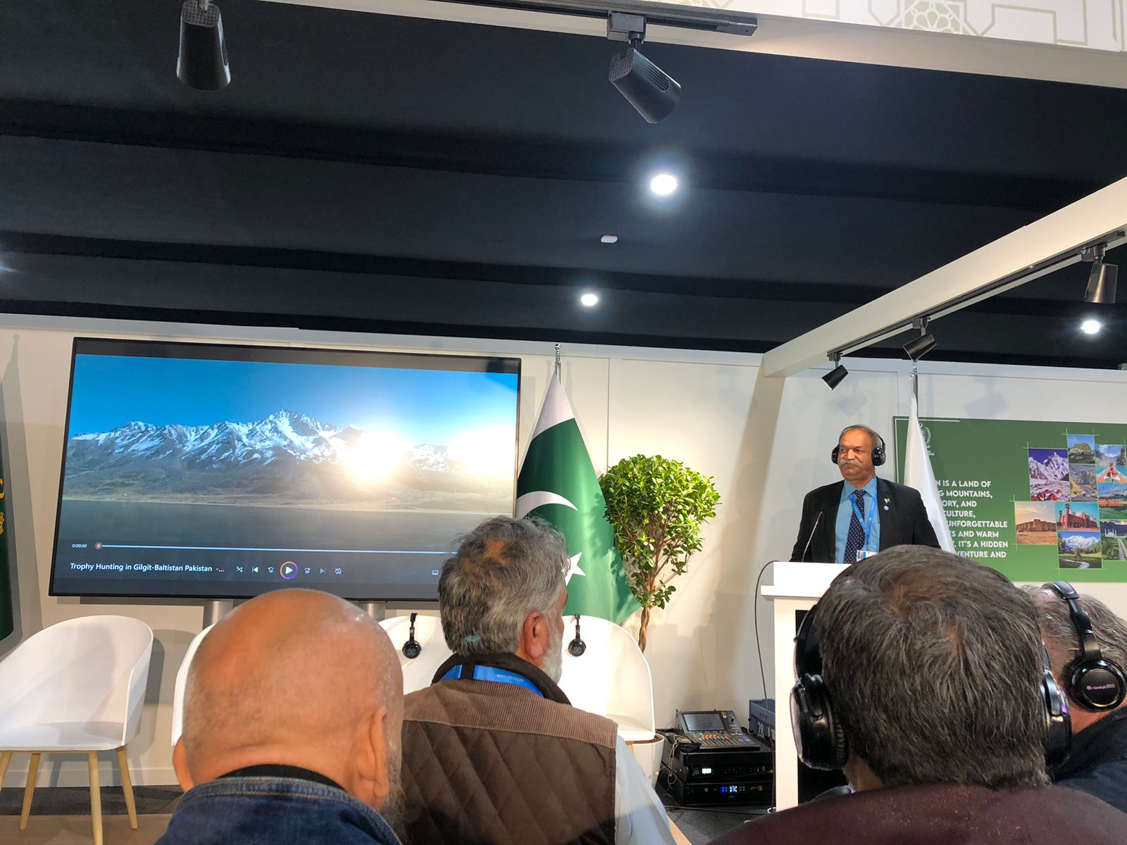
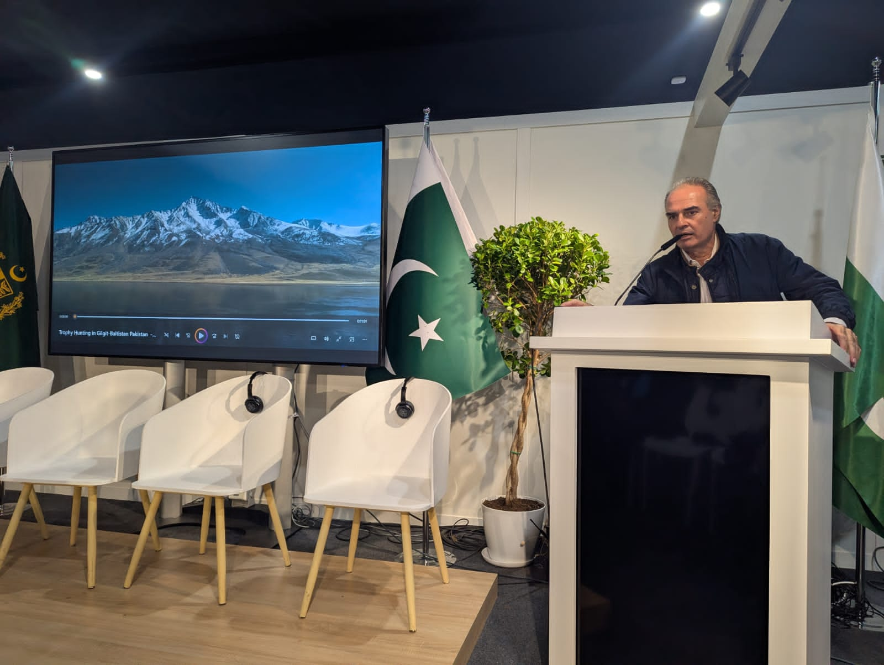

NEWS 4 COP 29
Tourism Day at COP 29: A Landmark Event
For the first time in COP history, Tourism Day was celebrated at COP 29, organized by UN Tourism, UNEP, and the State Tourism Agency of Azerbaijan. The Climate Hub Forum (CHF) actively participated in high-level discussions focused on aligning tourism policies with climate mitigation and adaptation goals.
Key Outcomes:
- Recognition of tourism’s dual role as both a vulnerable sector and a driver of climate solutions.
- Emphasis on advancing the Glasgow Declaration on Climate Action in Tourism.
- Acknowledgment of tourism's potential in promoting climate resilience.

Forum’s Strategic Highlights at COP 29
The Climate Hub Forum (CHF) demonstrated its leadership in climate justice, sustainable development, and empowering the Global South. CHF's participation in COP 29 underscored its role in advocating for impactful climate action.
Key Achievements:
- Advocacy for the Global South:
  - Led discussions on climate justice, equitable finance, and capacity building, emphasizing the unique challenges faced by countries in the Global South.
  - Presented the Pakistan National Climate Finance Strategy, highlighting innovative funding mechanisms for vulnerable regions.
  - Advocated for increased access to multilateral funds for adaptation, loss and damage, and resilience projects in Pakistan, Africa, and other developing countries.
- Regional Collaborations and Partnerships:
  - Partnered with Pakistan’s Ministry of Climate Change to advance the One Million Trees Project and Mangrove Restoration initiatives.
  - Collaborated with African organizations on projects focused on climate-resilient agriculture, renewable energy, and sustainable tourism.
  - Participated in sessions with UN Habitat, UNWTO, and other regional bodies to integrate sustainable tourism into climate resilience planning.
- Signed Agreements:
  - Baku Continuity Coalition: A framework to promote urban climate resilience across the Global South.
  - Multi-Sectoral Action Pathways (MAP) Declaration: Endorsed cross-sector partnerships for sustainable solutions.
  - Initiated joint urban development and resilience projects with UN Habitat.
- Innovative Projects Initiated:
  - One Million Trees Project: Launched in Taxila, aimed at combining heritage preservation with climate adaptation, with plans to scale nationwide.
  - Mangrove Restoration Project: Focused on mitigating coastal erosion in Sindh and Balochistan, supporting biodiversity and empowering local communities.
  - Art for Climate Change: Expanded globally, uniting artists, filmmakers, and cultural advocates to raise awareness and inspire climate action.

Metrics for Impact:
- 300+ participants attended CHF-led sessions at COP 29.
- Partnerships established with 15+ organizations from the Global South.
- Engaged 3000+ people and organizations through advocacy and collaborative projects.

Through these strategic initiatives and impactful discussions, CHF solidified its position as a key player in the global climate dialogue, setting a powerful foundation for continued action and partnerships leading up to COP 30.
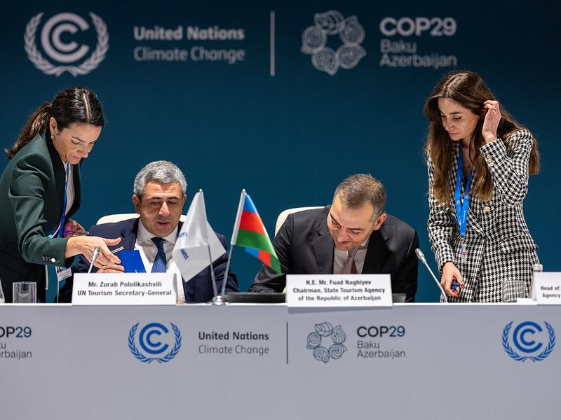

NEWS 5
CHF Champions Global South Capacity-Building at COP 29’s Marketplace Day
At COP 29 in Baku, the Climate Hub Forum (CHF) played a pivotal role in the Capacity-Building Tools & Methodologies Marketplace Day. Participating at the session organized by United Nations University's Institute for Environment and Human Security (UNU-EHS), CHF contributed to the Urban Futures and Sustainability Transformation (FAST) Program, emphasizing the need for equitable capacity-building initiatives tailored to the Global South.
Bridging the Capacity Divide
During a panel discussion, Erum Khan highlighted the persistent disparities between the Global North and South, advocating for deeper collaborations to bridge capacity gaps. She emphasized that addressing these disparities is crucial for effective climate action and sustainable development in vulnerable regions.
Showcasing Transformative Urban Initiatives
CHF members shared success stories from the Global South, illustrating how community-led initiatives can drive urban sustainability and resilience. These narratives underscored the importance of localized solutions and the empowerment of communities in addressing climate challenges.
Strategic Collaborations and Future Directions
CHF's participation in the Marketplace Day aligns with its broader mission to amplify the voices of the Global South in global climate dialogues. By fostering partnerships and advocating for inclusive policies, CHF aims to ensure that capacity-building efforts are responsive to the unique needs of developing nations.
As COP 29 concluded, CHF reaffirmed its commitment to advancing climate justice and sustainable development through collaborative efforts and strategic initiatives, setting the stage for continued impact leading up to COP 30.

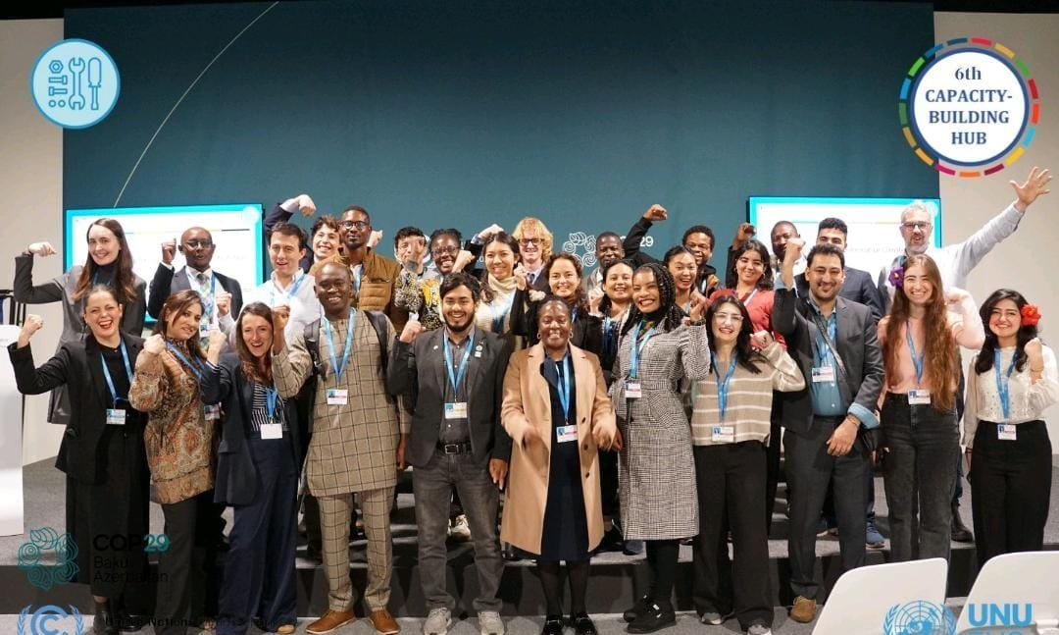

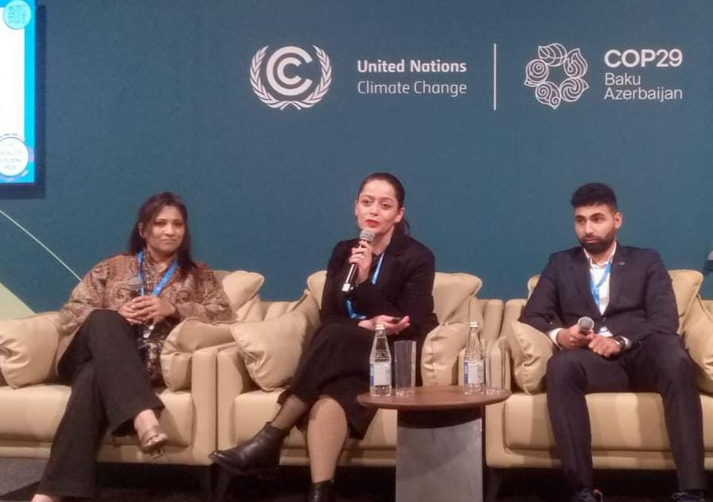

NEWS 6
Climate Hub Forum Strengthens Climate Diplomacy at COP 29 Through Strategic High-Level Engagements
During COP 29, the Climate Hub Forum (CHF) solidified its role as a key Global South voice by engaging in a series of high-level diplomatic meetings and sessions. These engagements reinforced CHF’s commitment to climate justice, equity, and international collaboration, while amplifying the importance of inclusive climate diplomacy.

Key Diplomatic Highlights:
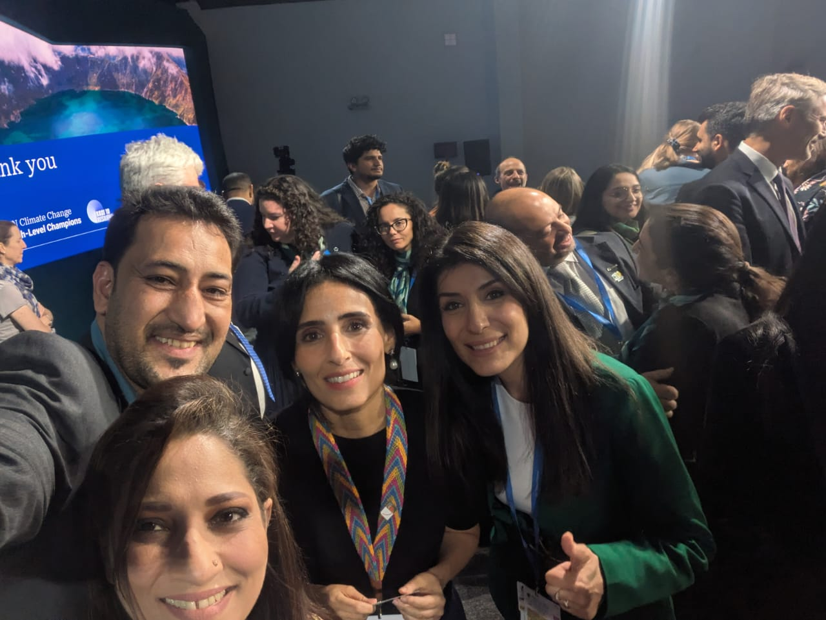
Meeting with Razan Al Mubarak, UN Climate Change High-Level Champion for COP 28
In a pivotal dialogue, CHF Chairperson Erum Khan met with Razan Al Mubarak to discuss strengthening ties between Global South actors and UN Climate Champions. Razan acknowledged CHF’s impactful advocacy work, particularly the “Art for Climate Change” initiative, and expressed interest in future collaborations that combine creative engagement with climate policy.

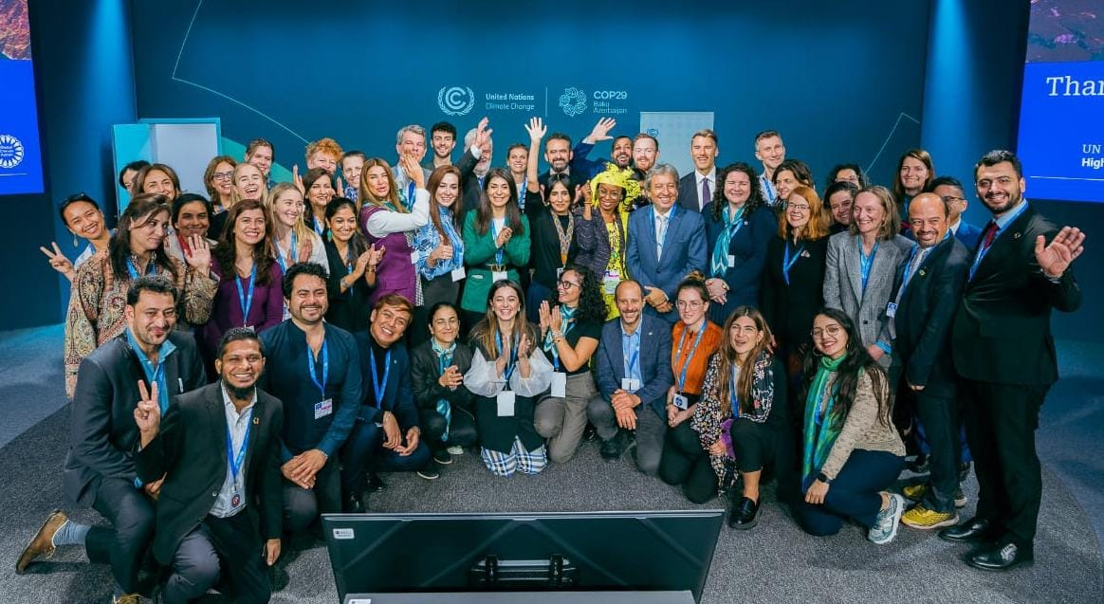
Exchange with Nigar Arpadarai, COP 29 High-Level Champion
In a forward-looking discussion, CHF explored potential alignment with COP 29’s Azerbaijani Presidency. Nigar Arpadarai expressed appreciation for CHF’s mission and pledged support for amplifying Global South voices, especially on issues of adaptation, financing, and local climate action.

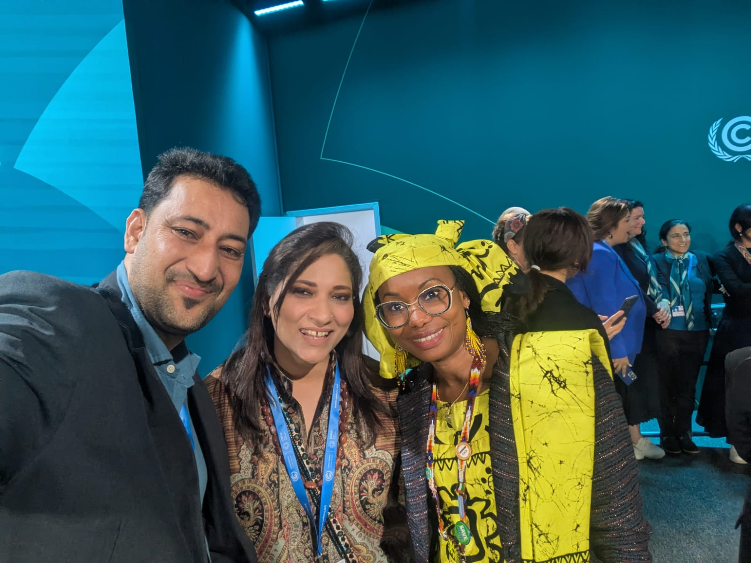
Engagement with Hindou Oumarou Ibrahim, President of the Indigenous Peoples’ Forum & UN SDG Advocate
At the High-Level Champions’ closing session, CHF reaffirmed its dedication to integrating indigenous wisdom into climate strategies. The conversation with Hindou centered on preserving ancestral knowledge systems and building cross-cultural climate resilience frameworks.

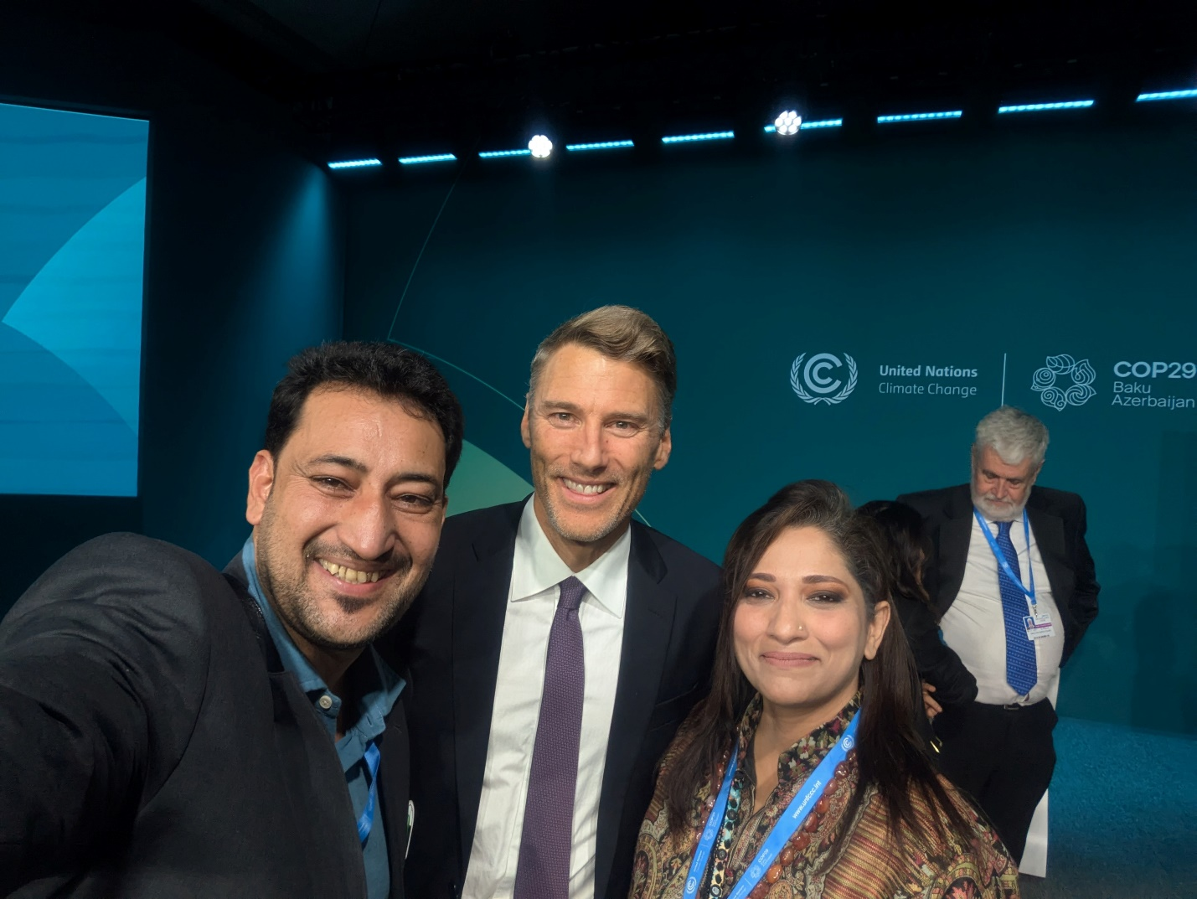
Dialogue with Vancouver’s Mayor at UN Habitat Ministerial Meetings
CHF engaged in impactful urban policy dialogue with the Mayor of Vancouver, emphasizing the role of local governance in climate adaptation. The exchange highlighted the shared challenges of urban climate resilience and sustainable development across geographies.

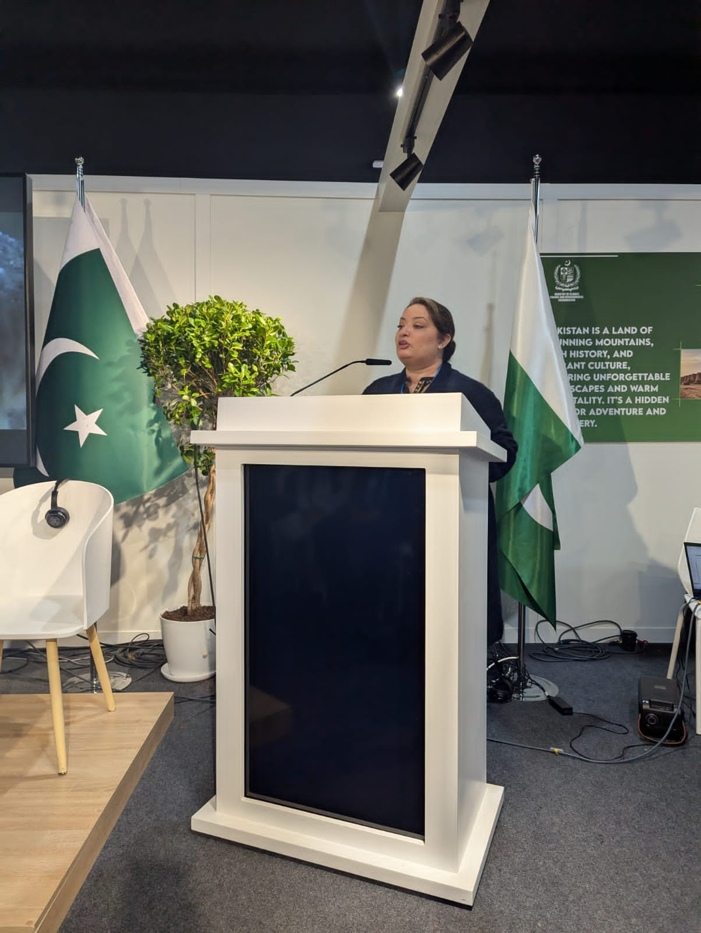
Strategic Discussion with Rubeena, Coordinator to the Prime Minister of Pakistan
Held at the Pakistan Pavilion, this key meeting explored synergies in climate finance, sustainable tourism, and resilience-building. The discussion laid the groundwork for deepened collaboration between CHF and the Government of Pakistan on national and regional climate strategies.

Meeting with the Secretary of Climate Change, Bangladesh
CHF welcomed insights on Bangladesh’s pioneering “3 Zero Theory” (Zero Poverty, Zero Unemployment, Zero Carbon Emissions). The dialogue reflected a shared vision for resilient, inclusive growth in South Asia, and a commitment to regional solidarity in addressing extreme weather vulnerabilities.

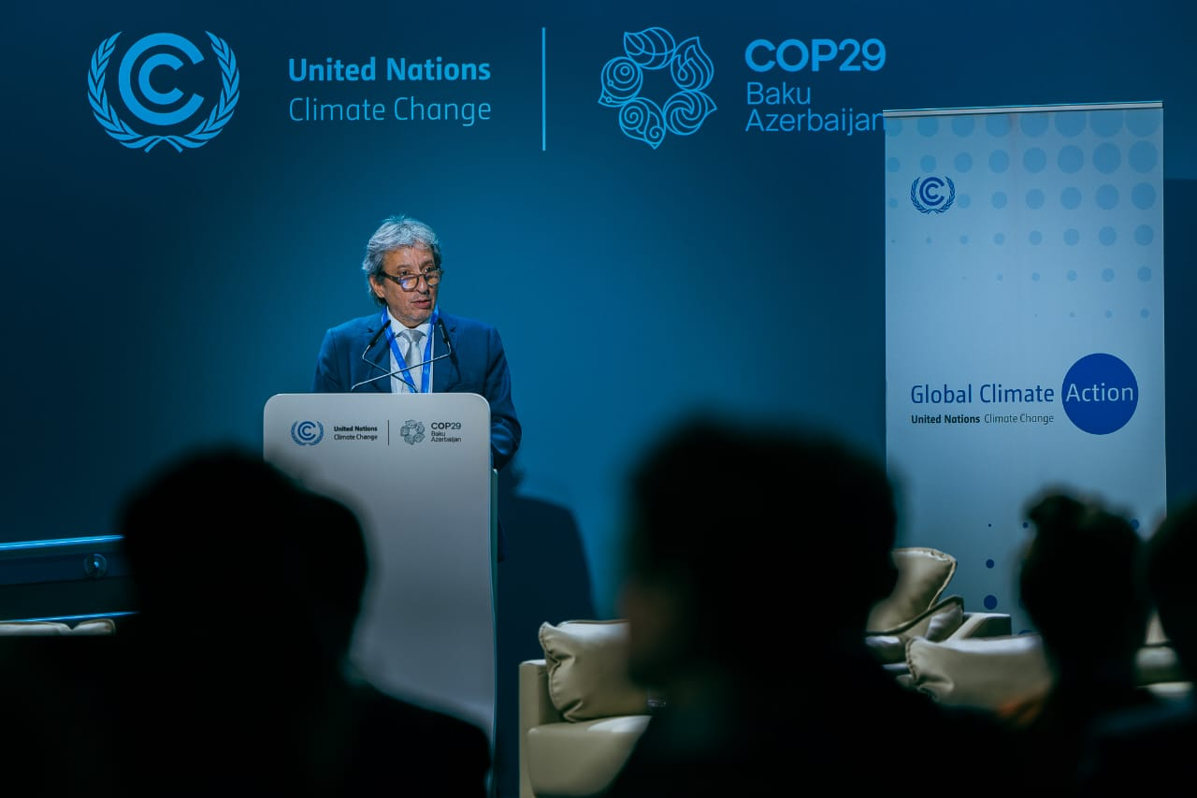
Bilateral with WWF Global Director
The Forum held strategic talks on advancing biodiversity protection, climate-smart ecosystems, and collaborative frameworks for environmental resilience. Both sides expressed interest in pursuing joint initiatives rooted in sustainability and conservation.

Exchange with Saudi Expert on Circular Carbon Economy
This meeting underscored the relevance of innovative technologies, including CCUS (Carbon Capture, Utilization & Storage), in achieving net-zero transitions. CHF welcomed Saudi Arabia’s expertise and explored ways to contextualize the Circular Carbon Economy for Global South applications.

Engagement with European Union Representative
CHF presented its climate diplomacy portfolio, particularly its initiatives on sustainable tourism and community resilience. The EU representative acknowledged CHF’s efforts and welcomed future dialogue on funding partnerships and strategic cooperation with EU-led climate platforms.

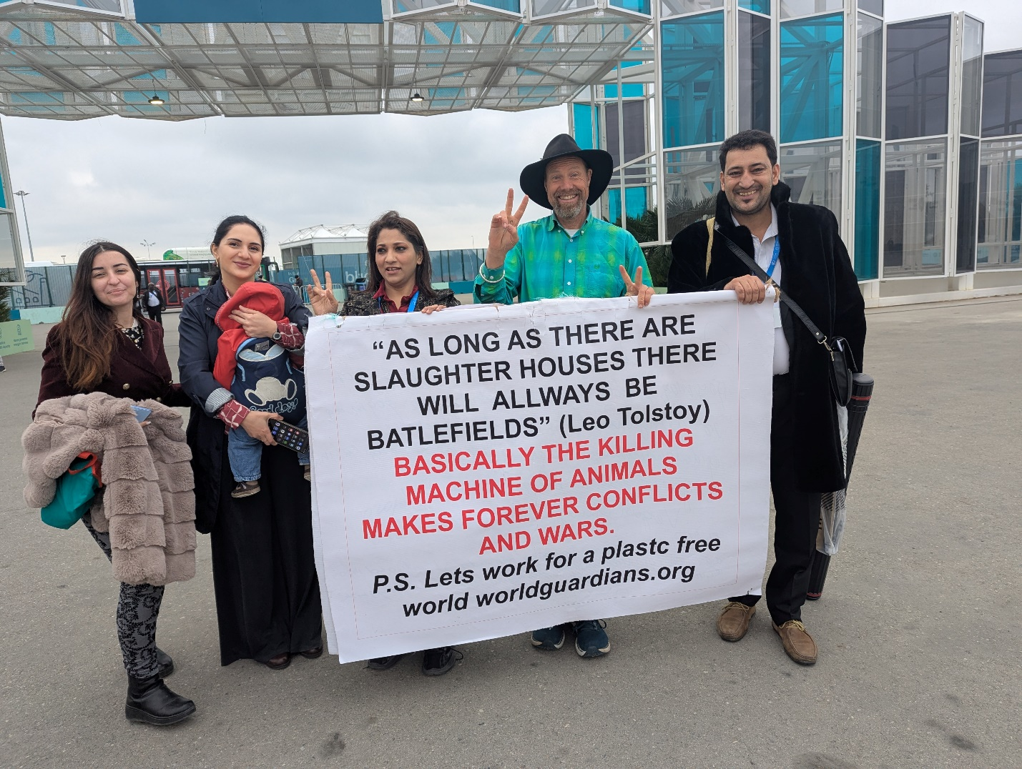
Meeting with Julian Bliss, World Guardians
A shared commitment to planetary stewardship emerged in this inspiring dialogue. Both parties agreed to collaborate on hope-driven climate solutions and joint campaigns to protect vulnerable populations and ecosystems.

Engagement with Senior Researcher from Islamabad (UN-Affiliated PhD)
Scientific insights on South Asian climate adaptation were exchanged, including policy models rooted in empirical data. The Forum emphasized its dedication to evidence-based advocacy and research-backed regional planning.

Session Participation at the Oman Pavilion
CHF attended a high-level session at the Oman Pavilion, gaining insights into the country’s integrated approach to climate adaptation, energy transition, and sustainable development policy.

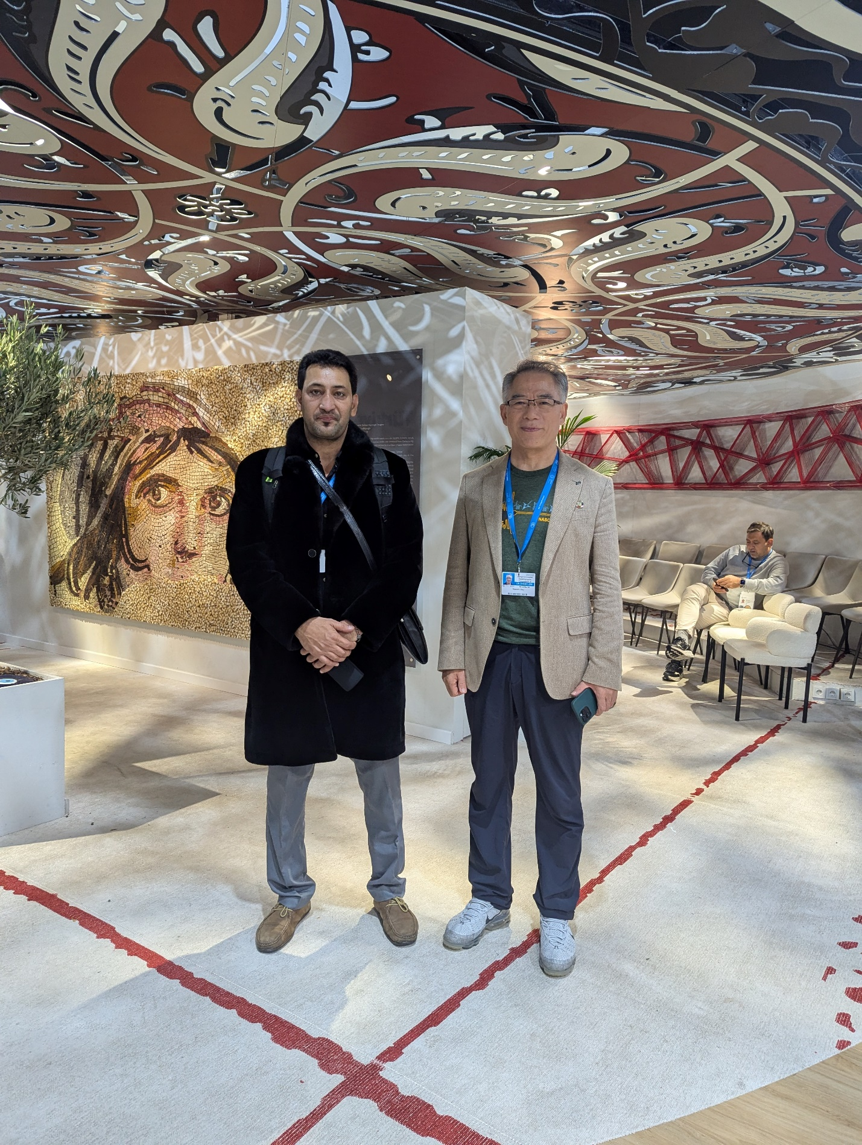
Through these high-level engagements, the Climate Hub Forum further positioned itself as a credible and dynamic force in international climate diplomacy. By advocating from the Global South, engaging multilaterally, and building coalitions across governments, institutions, and civil society, CHF reaffirmed its leadership role heading into COP 30.

